TEAM :12

**12. Designing Visually Appealing Certificate For A Debate Competition Using Canva.**

**SYLLABLE**

1. **Introduction**
2. **What is graphicdesing with canva**
3. **Empathy map**
4. **Brainstorm &idea prioritization**
5. **PDF &PNG of the desing in canva**
6. **Project documetation**
7. **Video demonstration**
8. **conclusion**

1.INTRODUCTION:

The "Crafting Visually Striking Certificates for a Debate Competition using Canva" project focuses on creating impressive and memorable certificates to recognize the participants, winners, and contributors of a debate competition. A well-designed certificate not only serves as a token of achievement but also reinforces the prestige and professionalism of the event.

* Skills you will develop

1. Color Theory and Psychology
2. Image Editing and Manipulation
3. Motion Graphics and Animations
4. Social Media Graphics

2.WHAT IS GRAPHICDESING WITH CANVA :

* Graphic design is a form of visual communication consisting of illustrations, typography, and photography, which helps to communicate target audience visually. Using graphic design we can create communicative visual content like logos, brochures, visiting cards, posters, newsletters, banners, web templates, etc. Using graphic software’s like Photoshop, illustrator, and Canva.

3.EMPATHY MAP:

1. An empathy map is a tool used in design thinking to build an emotional representation of a user or the customer.
2. By listening to the student and creating the map with the child, a relationship begins.

* MY WORK OF EMPATHY MAP IMAGE:

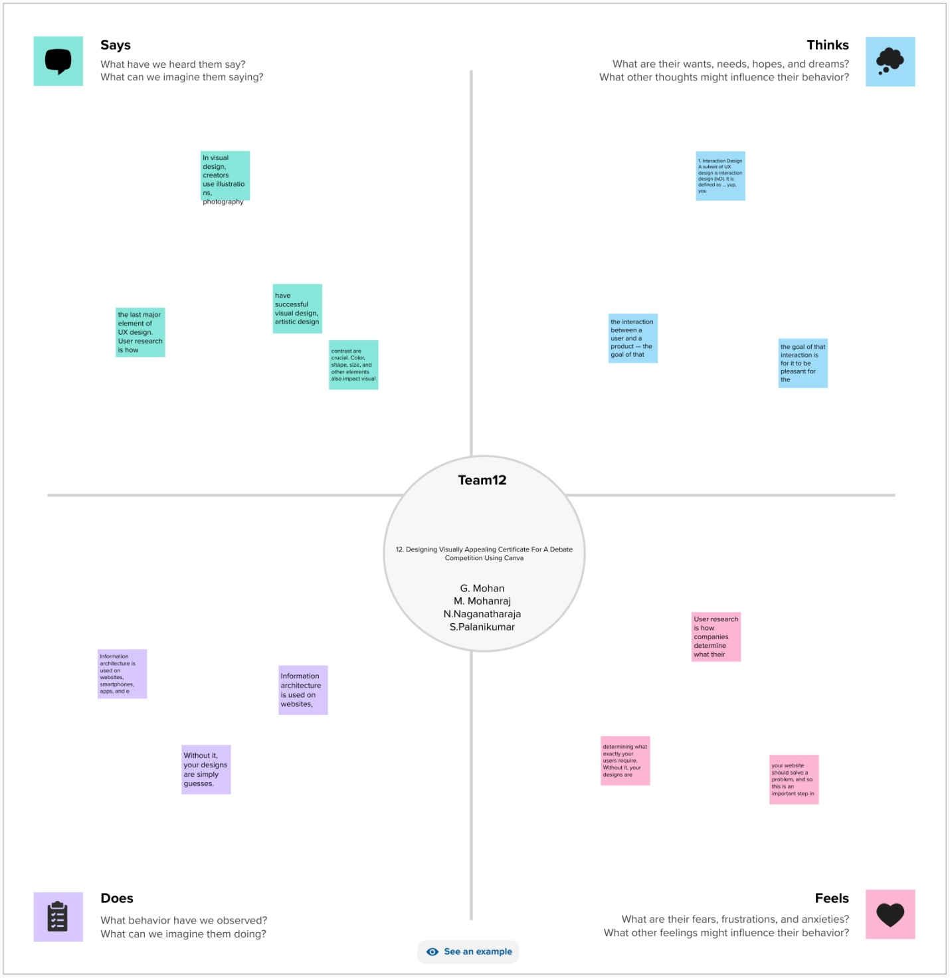

* MY EMPATHY MAP USE IT:

1. Start with the GOAL section, by defining WHO will be the subject of the Empathy Map and a goal: something they need to DO. ...
2. Once you have clarified the goal, work your way clockwise around the canvas, until you have covered Seeing, Saying, Doing, and Hearing.
3. My team is very use points of the work of into project in empathy map works.
4. One stand is one point use of the work

3.BRAINSTORM &IDEA PRIORITIZATION:

* Define goal and invite stakeholders. The first step in the process is to clearly define the goal(s) of your brainstorming session.
* Define your problem statement.
* Brainstorm!
* Group ideas together by theme.
* Prioritize solutions.
* TEAM WORK 4 PERSON WORK:
* Desing your industry trends in you’re consuming information relevant to your industy all day.
* If a particular item you come across stays with you-or likes you-there is probably a great info graphic in idea some where in there work.
* Here’s an example of a marketing tyends piene Microsoft make for the make ting indus
* IMANGE WORK IN BRAINSTORM:

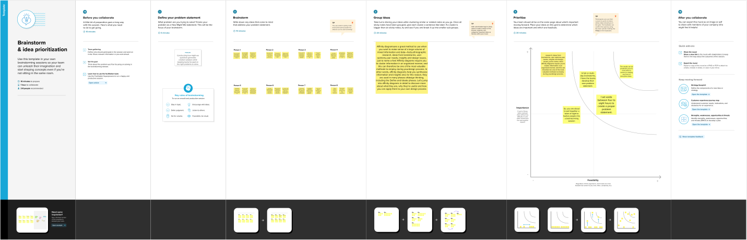  
5.PDF&PNG THEDESING IN THE CANVA:

1.CANVA CERTIFICATE EDITING FOR PHOTO EDITAND CERTIFICATE:

* Graphic design is canva use is certificate new model desinging editing cate in canva project.
* Winner certificate frist 1

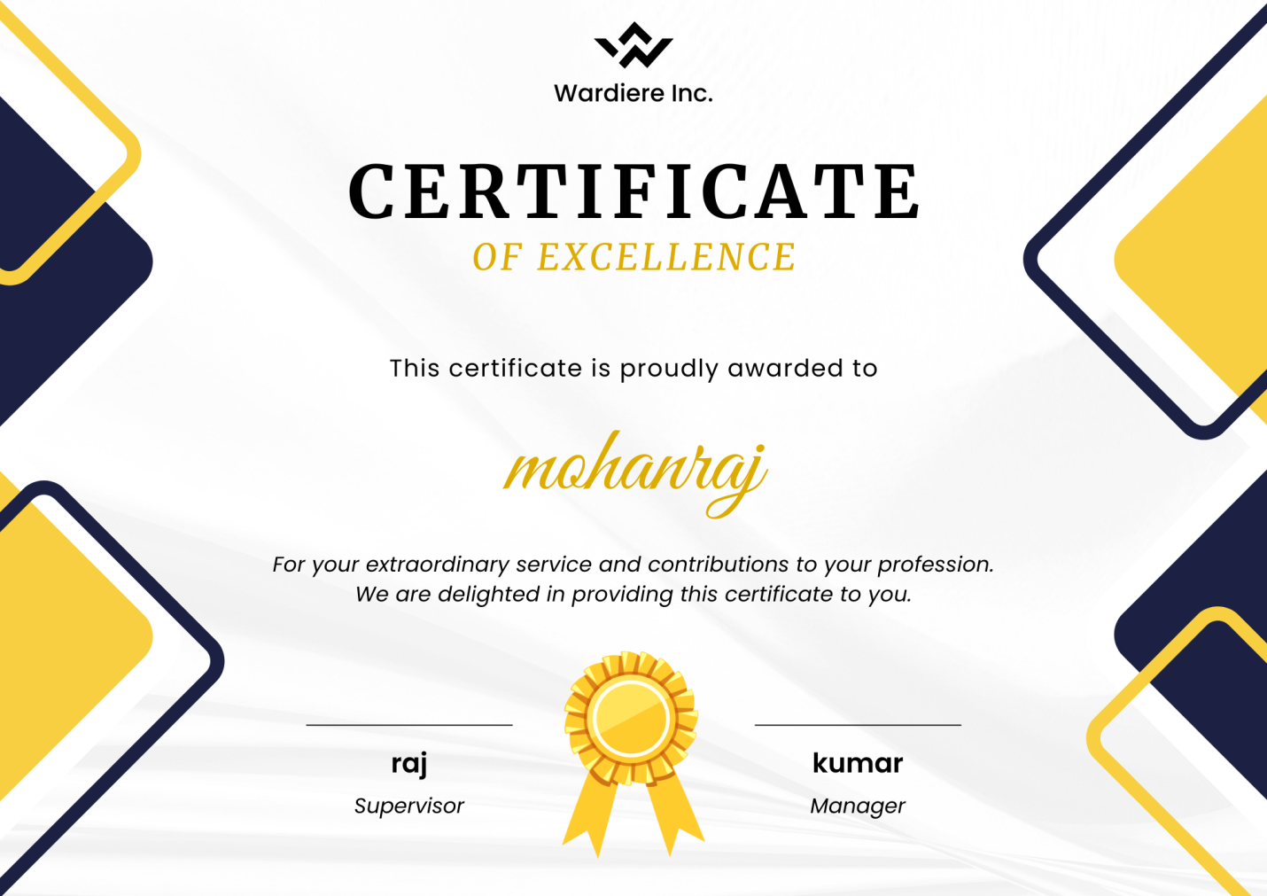

* CANVA EDITING KEY WORK:
* Canva app opan is mobile phone is the canva project use in the canva.
* Canva is new + ican is the canva.
* “SEARCH” open is canva.
* 2st Your Tittle is certificate 29.7 *21cm .
* Canva is my botton click on.
* The canva is write page open on.
* New opan is canva.
* Search a4 (landscape) tamplates is canva.
* Templates and styles (search) open.
* Certificate all 15318 temples in the canva.
* “Crete blank” click.
* All the open certificate in canva app use.

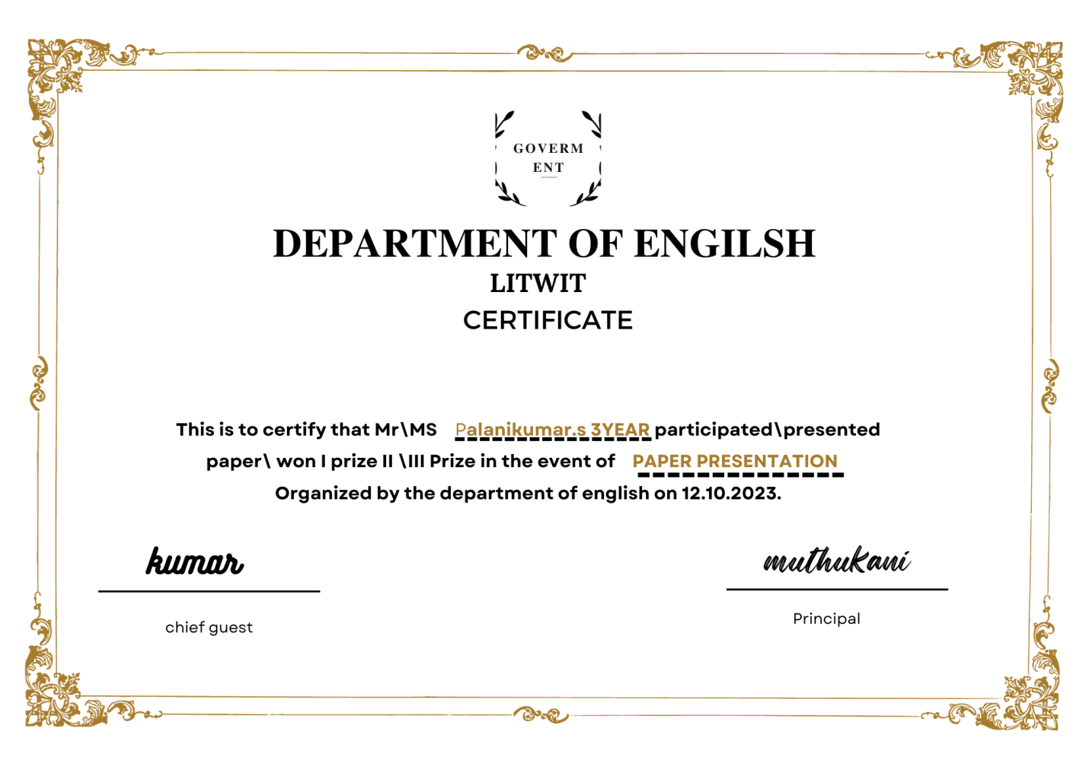

* COLLEGE WINNAR CERTIFICATE LITWIT:
* Your new use on the canva.
* Your style in the canva project on canva

Edit the document font change your name and tittle name typing use canva.

* Canva change you font and font size and color and formet and spacing and effets and animate transparency change in the canva editing work.
* Full size change in canva use replace and color and effects and filters adjust and crop and filp and animate and transparency and layers and info and more change your full size in the canva app on.
* Elements change graphics click on.
* The generate your own.
* Open on the canva work.
* Element change on the canva.
* Color change your color in the canva.
* Edit in Canva certificate save your on the canva app.
* Save the image download ican click in canva.
* PNG AND PDF save as
* Save download settings.
* Download click on canva.
* Your editing in canva image save in the gallery .
* My mobile phone save in gallery.

6.PROJECT DOCUMENTATION:

1. Project documentation consists of a collection of documents that the project manager creates during the project's development process. The project team is expected to follow certain procedures, specifications, and guidelines for such documents, including a project plan, schedule, and budget.

2. Documentation encourages knowledge sharing, which empowers your team to understand how processes work and what finished projects typically look like.

3.All project documents are important, but the Statement of Work (SOW) is easily one of the most important because it's made at the outset of a project and outlines everything that needs to go into your project.

7.VIDEO DEMONSTRATION:

1. Demonstration videos are an effective and engaging way for you to share knowledge of how to do specific tasks or steps on a computer.

2.A demonstration video is simply a video (a screen recording, or walk-through).

3. that shares the step-by-step “how-to” for accomplishing a specific task on the computer.

ME PROJECT VIDEO LINK:

<https://youtu.be/gMF9PTxnYuY?si=09A0DYICUdh1e7ff>

* My certificate video team person work link.

8.conclusion:

1.The designing visually appealing certificate for a debate comprtition in the me team one and four person in the editing in certificate.